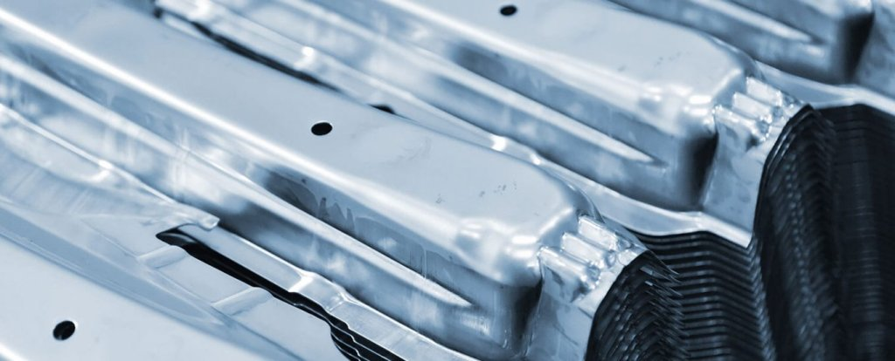

CARBON-X®-AL – The new low friction coating for aluminum forming

With the CARBON-X-AL®, our new friction-reducing, hard and smooth coating solution, you will achieve even more cost-efficient production results in aluminum forming. The multilayer-coating with friction-reducing effect works with less lubricant, thereby reducing both your costs and your ecological “footprint.”

Up to 76% more performance compared to similar coatings

During the impact extrusion of aluminum discs, an increase in performance of approx. 76 % was achieved compared to chemically comparable coating systems. At the same time, it showed that using the eifeler sputter technology (150 – 200 °C) resulted in a low temperature load on the tool, treating the tool more careful.

Coating properties

|  |  |
| --- | --- |
| Hardness | 2.400 ± 400 HV |
| Coating thickness | 3 – 4 µm |
| Maximum operating temperature | 325 °C / 617 °F |
| Friction coeff. against steel | 0,05 – 0,1 |
| Roughness | R0: 0,011 µm RZ: 0,109 µm |
| Colour | Dark gray |

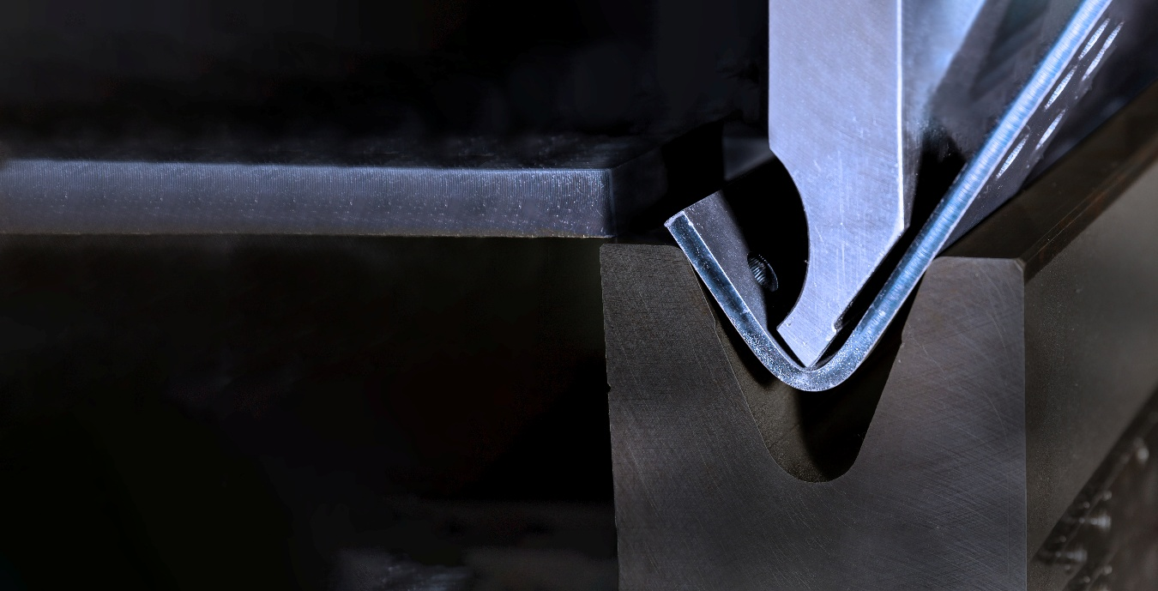

Cares for environment, reduces costs

* As you need less lubricant in your production, you reduce the amount of environmentally hazardous materials.
* The lower amount of lubricants reduces your costs for material and waste disposal as well as the time for cleaning.

LINK TO DATA SHEET

LINK TO APPLICATION STORY